Instructions for making an appointment

- Access URL: https://pku.mywconline.com

- Register for an account with your pku email.
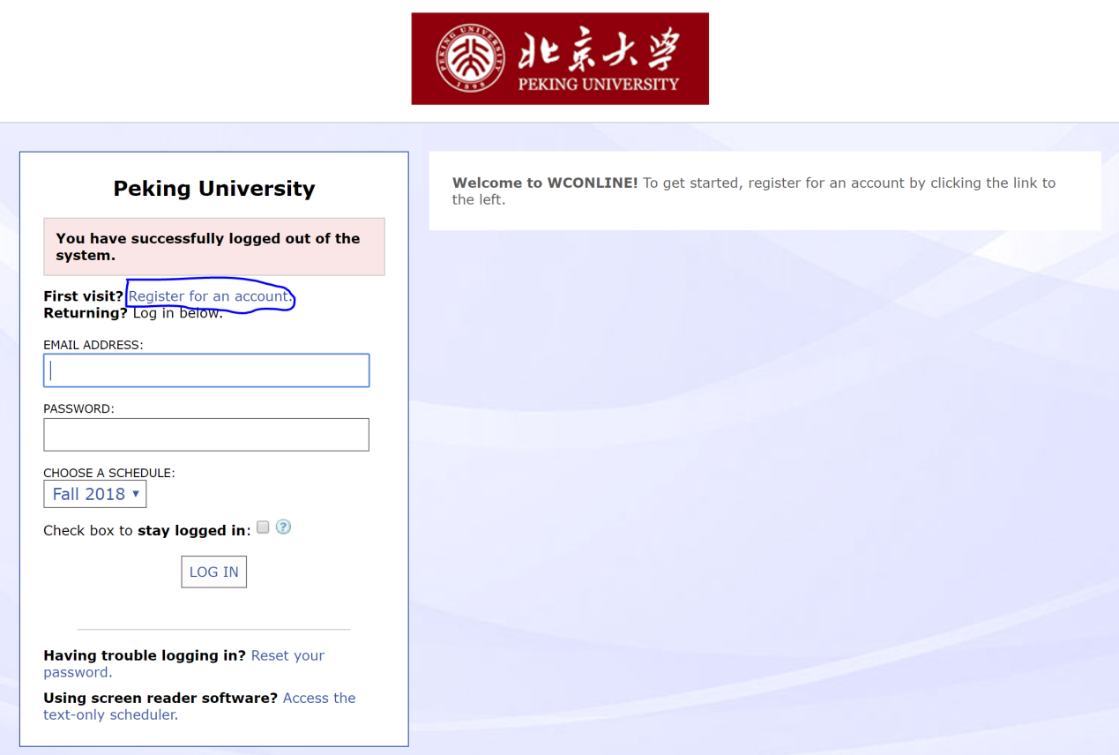

- When you have received the confirmation email, you can log in and make your appointment by clicking on one of the white slots.
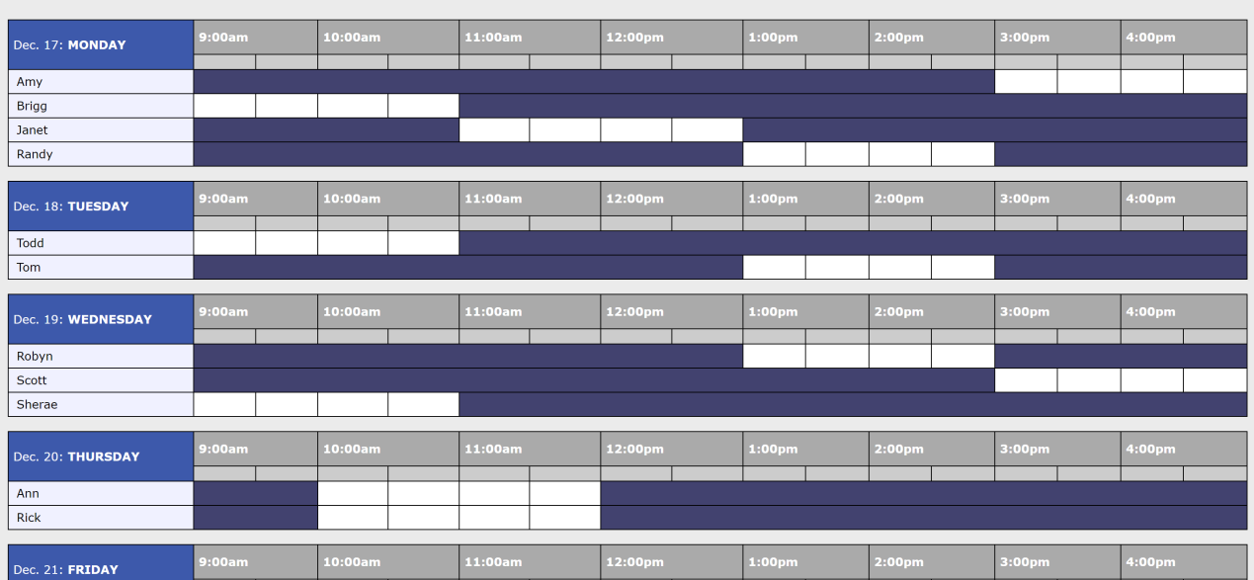

- Then fill in the blanks in the pop-up window. For “Course” and “Instructor” please fill in the blanks with the name of the English course you are currently taking and that of your instructor. For “What would you like to work on today?” please state the purpose of your appointment.
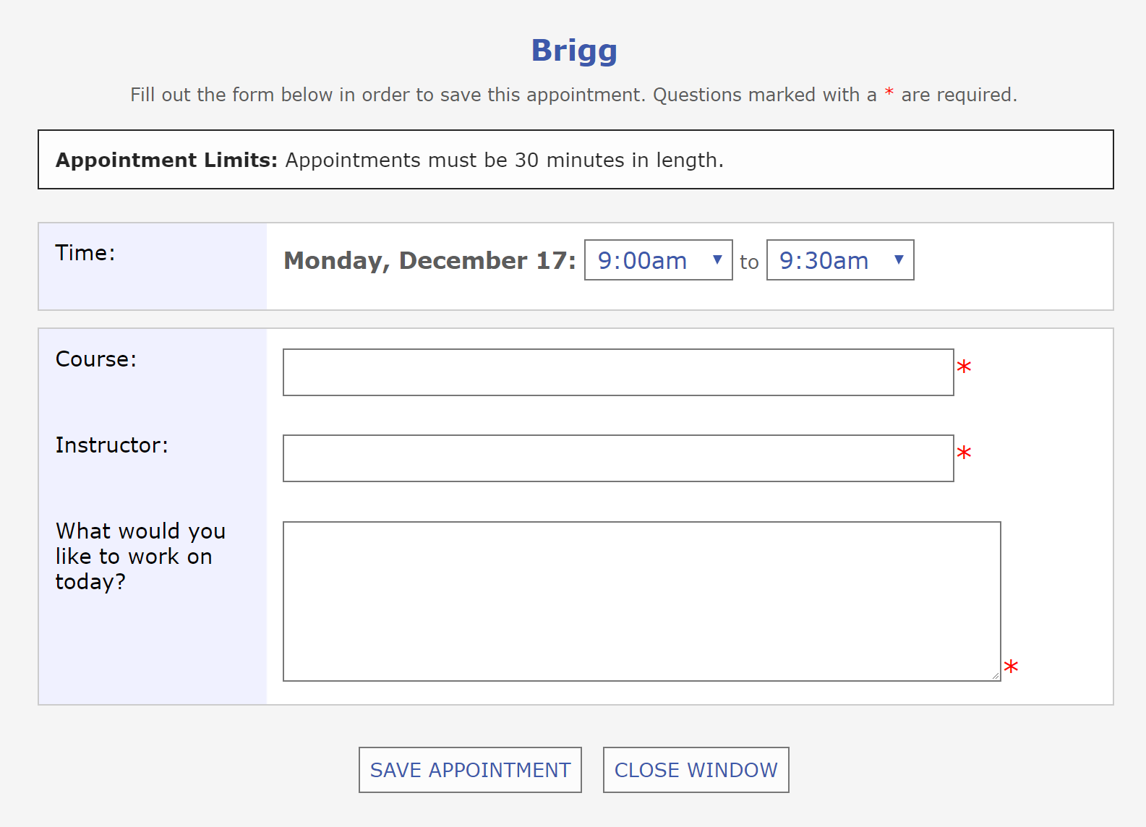

- Click “save appointment” and complete your appointment.

